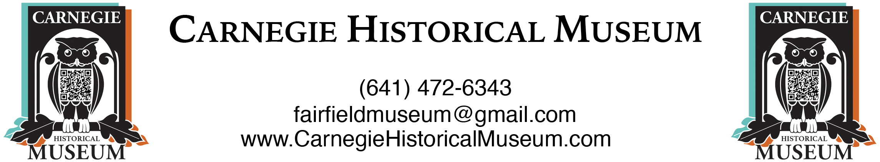

Volunteer Application

Full Name ___________________________________________________________________________________________________

Email Address _______________________________________________________________________________________________

Phone Number ______________________________________________________________________________________________

Address ____________________________________________________________________________________________________

EMERGENCY CONTACT INFORMATION:

Name ___________________________ Relationship ____________________________ Phone _____________________________

18 years of age or older? __________ Lift up to 40 pounds easily? __________ Can you climb 3 flights of stairs? __________

Describe your computer skills: Great Nonexistent Word Processing Only

Current employment status: full time part time retired student unemployed

Your current or most recent employer (your job title, name of company, address, phone)

Special skills, work experience, or training that you think might qualify you for museum work. Circle relevant skills:

Data entry Information Technology Graphic Design Cust. Service Editing Proofreading Housekeeping

General Office Work Woodworking Writing Display Design Sewing Filing Tour guide Marketing

Photography Videography Online Research Research Digitizing Analog Media Transcribing Family

History Research Landscaping Cleaning Services Maintenance

Other: Please list and describe

Why would you like to volunteer at the Carnegie Historical Museum?

The museum is open Tuesday through Friday 11a.m. - 4 p.m. In addition, on the first Friday of every month, we are open 6 p.m. -
9 p.m. to accommodate those attending Fairfield's "First Fridays" events. (Please list the days and times you expect to be available to work.)

I certify that my statements on this form are true and agree that any falsification or omission by me in connection with this application or attachments thereto shall constitute sufficient cause for termination of any volunteer service/internship resulting therefrom. I authorize the Museum to obtain information concerning me from former employers, schools, and military service, as well as police reports and other legal documents, and I release all concerned from any liability in connection therewith.

I acknowledge that the Carnegie Historical Museum has the right to run a background check on me.

Signature _______________________________ Date ____________________

Print name ___________________________

